OS LAB
Practical – 6
- Create a client-server application using Named Pipes (FIFOs). The client sends messages and the server processes and responds to them. Analyze FIFO behavior when multiple clients communicate simultaneously.

Create a POSIX signal handling program that captures SIGINT, SIGTERM, and SIGUSR1. Demonstrate asynchronous event handling and explain the role of signal handlers.

Server.c

#include <stdio.h>
#include <stdlib.h>
#include <string.h>
#include <fcntl.h>
#include <unistd.h>
#include <sys/stat.h>

#define FIFO1 "client_to_server"
#define FIFO2 "server_to_client"

int main()
{
char message[100];
char response[150];

mkfifo(FIFO1, 0666);
mkfifo(FIFO2, 0666);

printf("Server started...\n");

int read_fd = open(FIFO1, O_RDONLY);
int write_fd = open(FIFO2, O_WRONLY);

while (1)
{
memset(message, 0, sizeof(message));

read(read_fd, message, sizeof(message));

printf("Client message: %s\n", message);

if (strcmp(message, "exit") == 0)
{
strcpy(response, "Server shutting down.");
write(write_fd, response, strlen(response) + 1);
break;
}

snprintf(response, sizeof(response),
"Server processed: %s", message);

write(write_fd, response, strlen(response) + 1);
}

close(read_fd);
close(write_fd);

unlink(FIFO1);
unlink(FIFO2);

return 0;
}

client.c

#include <stdio.h>
#include <stdlib.h>
#include <string.h>
#include <fcntl.h>
#include <unistd.h>

#define FIFO1 "client_to_server"
#define FIFO2 "server_to_client"

int main()
{
char message[100];
char response[150];

int write_fd = open(FIFO1, O_WRONLY);
int read_fd = open(FIFO2, O_RDONLY);

while (1)
{
printf("Enter message: ");
fgets(message, sizeof(message), stdin);

message[strcspn(message, "\n")] = '\0';

write(write_fd, message, strlen(message) + 1);

memset(response, 0, sizeof(response));

read(read_fd, response, sizeof(response));

printf("Server response: %s\n", response);

if (strcmp(message, "exit") == 0)
break;
}

close(write_fd);
close(read_fd);

return 0;
}
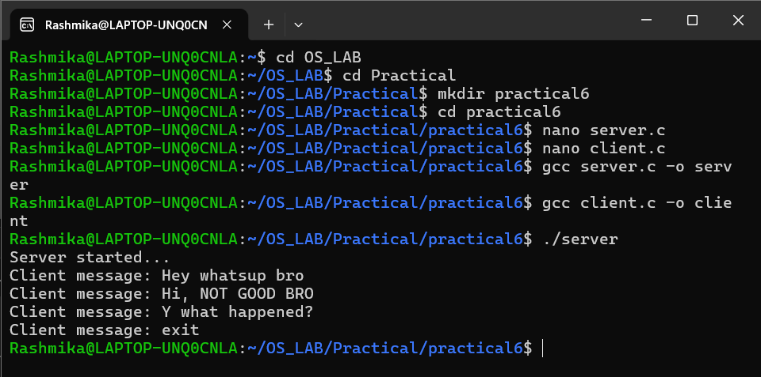
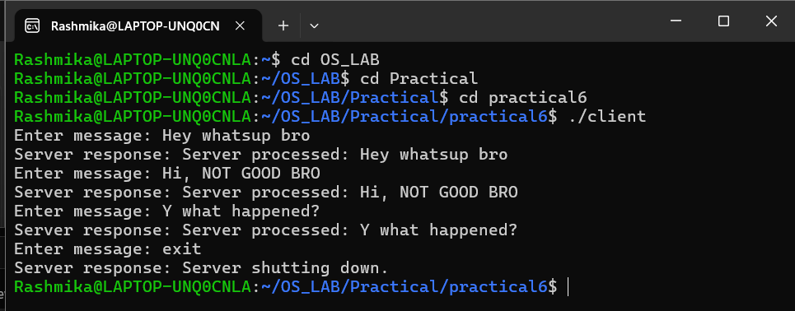

Signal.c
#include <stdio.h>
#include <stdlib.h>
#include <unistd.h>
#include <signal.h>

void handle_signal(int sig)
{
if (sig == SIGINT)
{
printf("\nSIGINT received. Ctrl+C detected.\n");
}
else if (sig == SIGTERM)
{
printf("\nSIGTERM received. Terminating process...\n");
exit(0);
}
else if (sig == SIGUSR1)
{
printf("\nSIGUSR1 received. User-defined event occurred.\n");
}
}

int main()
{
signal(SIGINT, handle_signal);
signal(SIGTERM, handle_signal);
signal(SIGUSR1, handle_signal);

printf("Process ID: %d\n", getpid());
printf("Waiting for signals...\n");

while (1)
{
printf("Program is running...\n");
sleep(2);
}
return 0;
}
